**Online Voting System**

A Project Report

submitted in partial fulfillment of the requirements of

Applied Cloud Computing for Software Development

by

**PATTUKOTA SAI TEJA**

**20AK1A3630**

**SHAIK HASEEB 20AK1A3631**

**C MANASA 20AK1A3618**

**BACHU SAI KUMAR 20AK1A3628**

**SHAIK MANSOOR 20AK1A3633**

Under the Esteemed Guidance of

**UMA MAHESWARI R**

# ACKNOWLEDGEMENT

We extend our sincere gratitude to all individuals who played a vital role in the successful completion of this Online Voting System project.

First and foremost, we express our heartfelt thanks to our supervisor, UMA MAHESWARI R, whose guidance and mentorship have been invaluable throughout this endeavor. Her insightful advice, unwavering encouragement, and constructive criticism served as a constant source of innovative ideas and inspiration, ultimately contributing to the successful culmination of this dissertation. The confidence she placed in us was a driving force, motivating us to strive for excellence. It has been a privilege to work under her mentorship over the past year, and we are grateful for the support she provided not only in the context of the project but also in various academic aspects. Her lectures and teachings have not only enriched our understanding of the project but have also contributed to our growth as responsible professionals.

We would also like to acknowledge the support of all those who, directly or indirectly, contributed to the realization of this project. Their collective efforts have significantly enhanced the quality and impact of our work.

## ABSTRACT

* We are developing an on-line voting system by taking advantage of the centralized database with a web interface. The main concept of this project is to build a website, which should be able to allow people to cast their vote by online.
* Time saving, working load reduced, information available at time and it provide security for the data. During the election, the election commission of India has introduced a new method of polling by online voting system (OVS). The election commission will maintain this website.
* This is a simple, safe and secure method that takes minimum of time. We proceed our project with the assumption that each voter has a voter ID storing his/her unique identity including data.
* We are to maintain a centralized database of enrolled voters, the primary key of which is a unique national ID stored on the database. The database administrator is the control the website. Control of the process is entirely in the hands of the computer, and cannot be manipulated by any others.
* Integrity of the results is guaranteed; Preventing the chance of false voting (i e) high secured false proof voting. Generally voting has to be performing by user by going to the voting center.

# TABLE OF CONTENTS

Abstract 3

List of Figures 5

List of Tables 5

Chapter 1. Introduction 6

* 1. Problem statement 7
  2. Problem definition 7
  3. Expected outcomes 8
  4. Organization of the report 9

Chapter 2. Literature Survey 10

* 1. Brief Introduction of Paper 11
  2. Techniques used in Paper 11

Chapter 3. Proposed Methodology 13

* 1. System Design 14
  2. Modules used 14
  3. Data flow diagrams 16
  4. Advantages 17
  5. Requirement specifications 17

Chapter 4. Implementation and Results 19

* 1. Result 20

Chapter 5. Conclusion 21

* 1. Adavantages 22
  2. Scope 22
  3. References 23
  4. Appendix 24

**Github Link......................................................................................................................**

**Video Link........................................................................................................................**

# LIST OF FIGURES

|  |  |  |
| --- | --- | --- |
|  |  | **Page No.** |
| **Figure 1** | Data Flow Diagram | **14** |

# CHAPTER 1 INTRODUCTION

**CHAPTER 1 INTRODUCTION**

### Problem Statement:

* The traditional voting process is often marred by inefficiencies, accessibility challenges, and security concerns. In order to address these issues and enhance the democratic process, there is a need for the development and implementation of a robust Online Voting System.

Problem Definition:

The problem addressed in the document is the inefficiencies of the current offline voting system in India. The system requires a large workforce, is time-consuming, and has the potential for inaccuracies in the counting and voting process. The document proposes the development of a Smart Online Voting System to address these issues, aiming to provide a more effective, accessible, and secure method of voting. The system allows for both online and offline voting, incorporating technologies such as face recognition, OTP authentication, RFID, and a central database for result calculation. The proposed system seeks to modernize the voting process in India, aligning with the evolving electronic world and global standards, while promoting fairness, accessibility, and efficiency in elections.

### Expected Outcomes:

1. Improved Efficiency: The system aims to overcome the inefficiencies of the current offline voting system in India, such as the need for a large workforce and the time-consuming process of processing and publishing results. By allowing remote voting and incorporating technologies such as face recognition and OTP authentication, the system seeks to streamline the voting process and make it more efficient.
2. Accessibility and Convenience: The system enables users to vote remotely from anywhere using a computer or mobile phone, eliminating the need to physically visit a polling station. This enhances accessibility and convenience for voters, potentially increasing voter turnout.
3. Security and Integrity: The use of face recognition technology, RFID tags, and a central database for result calculation aims to ensure the security and integrity of the voting process. The system is designed to prevent vote tampering and provide a verifiable and secure voting experience.
4. Adaptation to the Electronic World: By embracing electronic voting systems and leveraging technologies such as face recognition and online voting, the system aligns with the evolving electronic world and global standards. It aims to modernize the voting process in India and adapt to the changing technological landscape.
5. Real-time Results: The system allows citizens to view election results in real-time, reducing the potential for vote tampering and providing transparency in the electoral process. This feature aims to enhance trust and confidence in the election outcomes.

Organization of the report:

The report is organized into several sections, including an abstract, introduction, architecture, existing work, methodologies, literature survey, working, conclusion, and references. The abstract provides an overview of the paper's focus on developing a Smart Online Voting System to address the inefficiencies of the current offline voting system in India. The introduction emphasizes the importance of fair and secure elections in a democratic society. The architecture section outlines the key components and technologies used in the proposed system, such as face scanning, RFID, and online/offline voting capabilities. The existing work section discusses the limitations of current voting systems and the need for a more accessible and efficient approach. The methodologies section details the use of microcontrollers, LCD displays, RFID, and push buttons in the voting system. The literature survey provides references to related works in the field of electronic voting systems. The working section explains the process of voting, including offline and online methods, face recognition, and OTP authentication. The conclusion summarizes the proposed method and its features, emphasizing the system's correctness, verifiability, and convenience. Finally, the references section lists the sources cited in the paper.

# CHAPTER 2 LITERATURE SURVEY

**CHAPTER 2 LITERATURE SURVEY**

In the paper ‘‘SEVEP: Verifiable, secure and privacy preserving remote polling with untrusted computing devices” author “AMNA QURESHI”, describes, to design a polling system which is flexible in polling, using fingerprint devices to provide an extra step of

authentication, allow different devices which is available to the voter, no usage of polling sheets and to generate poll tags. In the paper “Secure and Hassle Free EVM through deep learning face recognition” author “Ishani Mondal”, used neural networks after extracting the facial features of the voter and with that a reference to vote during election. If the details match the existing details the user is allowed to vote. In the paper “VOT-EL: Three Tier Secured State-Of The-Art EVM Design Using Pragmatic Fingerprint Detection

Annexed With NFC Enabled Voter -ID Card” author “, Anosmia Das”, proposed design, along with biometrics NFC technology is also taken into account. In the paper “Secure and Electronic polling system”, the authors AMNA QURESHI, DAVID MEGÍAS, HELENA RIFA-POUS described Se-VEP, an e-polling system enabled by Internet which provides

and protects the voter’s integrity, security, voter’s unique details, poll integrity, third party breaching, prevention of double voting, fairness in election, and coercion resistance, and preventing devices with virus which change the user’s decision in voting and giving false results which leads to lot of problems.

# CHAPTER 3 PROPOSED METHODOLOGY

**CHAPTER 3 PROPOSED METHODOLOGY**

### System Design

The system design will show the overall architecture of the system. The following block diagram indicates basic components and their interaction among the components. Each component capable of providing one or more functionalities.

### Modules Used

1.VOTER’S PANEL

* + 1. CANDIDATES PANEL

#### VOTER’S PANEL:

* 1. :REGISTER
  2. LOGIN
  3. CHANGE PASSWORD&FORGOTPASSWORD
  4. VOTE FOR CANDIDATE

#### CANDIDATES PANEL:

* 1. REGISTER
  2. LOGIN
  3. CHANGE PASSWORD&FORGOTPASSWORD
  4. SEE VOTING RESULTS
  5. LOGOUT

.

### Data Flow Diagram

A Data Flow Diagram (DFD) is a graphical representation of the "flow" of data through an information system, modeling its process aspects. A DFD is often used as a preliminary step to create an overview of the system, which can later be elaborated. DFDs can also be used for the visualization of data processing (structured design).

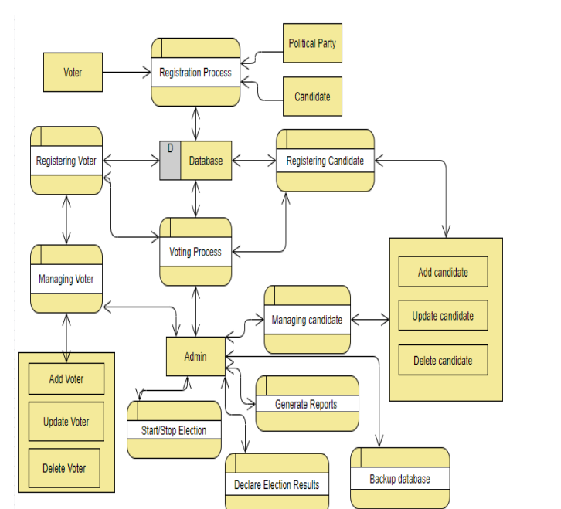

### Advantages:

1. Accessibility and Convenience: The system allows users to vote remotely from anywhere using a computer or mobile phone, eliminating the need to physically visit a polling station. This enhances accessibility and convenience for voters, potentially increasing voter turnout.
2. Efficiency: By incorporating technologies such as face recognition, OTP authentication, and RFID, the system aims to streamline the voting process, reducing the need for manual validation and physical transportation of voting machines. The use of a central database for result calculation also contributes to the efficiency of the system.
3. Security and Integrity: The system employs advanced technologies such as face recognition, RFID, and OTP authentication to ensure the security and integrity of the voting process. This helps prevent vote tampering and provides a verifiable and secure voting experience.
4. Real-time Results: The system allows citizens to view election results in real-time, reducing the potential for vote tampering and providing transparency in the electoral process.
5. Adaptation to the Electronic World: By embracing electronic voting systems and leveraging technologies such as face recognition and online voting, the system aligns with the evolving electronic world and global standards, contributing to the modernization of the voting process.

### Requirement Specification

##### Hardware Requirements:

* + - * Pentium-IV Processor
      * 256 MB RAM
      * 512 KB Cache Memory
      * 10 GB Hard Disk
      * Microsoft Compatible Keyboard (101 keys or more)

##### Software Requirements:

* + - * Operating System: Windows
      * Web Technology: PHP
      * Front-End: HTML, CSS, JavaScript
      * Back-End: PHP, MySQL
      * Web Server: Apache Server

**CHAPTER 4**

**Implementation and Result**

**CHAPTER 4 IMPLEMENTATION and RESULT**

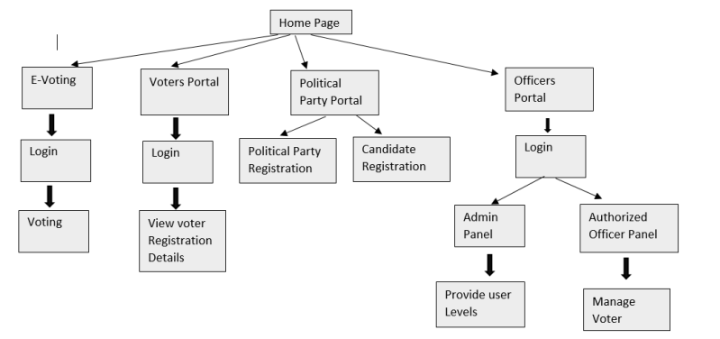

# CHAPTER 5 CONCLUSION

**CHAPTER 5 CONCLUSION**

### ADVANTAGES:

* Generally voting has to be perform by user by going to the voting center. Many users like army person or NRI cannot come to the voting place.
* Therefore, we have to implement a online voting system by which the users can vote over the online. It is one of the greatest advantages for NRI and person who go outside the country they can vote on online by our software.

### SCOPE:

The future scope of an online voting system project encompasses various potential enhancements and expansions to address evolving technological, societal, and regulatory needs. Here are some potential avenues for future development:

1. **Enhanced Security Measures**:
   1. Continuous improvement of security measures to defend against emerging cyber threats, including advancements in encryption techniques.
   2. Integration of blockchain technology to provide additional transparency, immutability, and tamper-resistance to the voting process.
2. **Accessibility and Inclusivity**:
   1. Development of features to enhance accessibility for voters with disabilities, such as support for assistive technologies, alternative voting methods, and multilingual interfaces.
3. **Usability and User Experience**:
   1. Iterative refinement of user interfaces and user experience design based on feedback from voters and usability testing.
   2. Implementation of personalized voting experiences tailored to individual preferences and voting histories.

# REFERENCES

* <http://www.oreilly.com/data/free/the-new-artificial-intelligence-market.csp>

# GITHUB LINK

* [**https://github.com/mr-unique-solver/onlinevotingsystem/**](https://github.com/mr-unique-solver/onlinevotingsystem/)